Flame in a sound wave
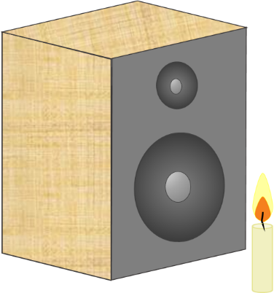
A lighted candle is put in front of a speaker
The speaker makes a sound wave.
The sound wave moves towards the candle.

What happens to the flame in a sound wave?
Put a tick (✓) next to the best answer.
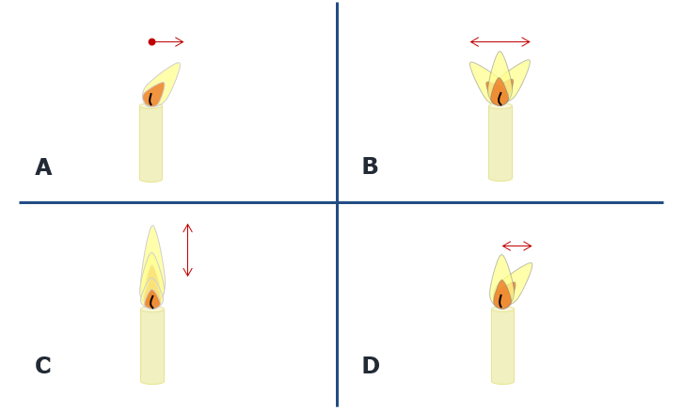
Physics > Big idea PSL: Sound, light and waves > Topic PSL4: Waves > Key concept PSL4.2: A wave model of sound
Diagnostic question
Flame in a sound wave

Overview
Learning focus: | As a sound wave (longitudinal wave) travels it transfers energy, as particles of the medium through which it travels are successively made to vibrate forwards and backwards along the direction in which the wave travels.
Observable learning outcome: | Describe the movement of each ‘particle’ of a longitudinal (sound) wave as the wave moves forward.
Question type: | Simple multiple choice
Key words: | Sound wave, vibrate, vibration

P | PRIOR UNDERSTANDING  This diagnostic question probes understanding of ideas that are usually taught at age 5-11, to aid transition from earlier stages of learning.

What does the research say?
Finding out exactly what students are thinking about sound can be difficult, as they often label ideas of ‘sound particles’ with scientific terms: sound waves, disturbances, or vibrations. Superficially it can appear that students have a scientific understanding when they do not (Fazio et al., 2008).
The motion of waves is hard for students to understand because waves form from large numbers of small scale events, such as the backwards and forwards movement of air particles in a sound wave. These small scale events are quite different to the form and motion of the wave (Caleon and Subramaniam, 2010). This can be seen clearly when spectators at a sports event stand up and sit down in sequence to produce a Mexican wave, which moves around the stadium. A model longitudinal wave can be set up similarly, with students who are standing in a line stepping forwards and backwards in sequence. This process transfers energy through a medium, but without the transfer of any bulk substance.
Ways to use this question
Students should complete the question individually. This could be a pencil and paper exercise, or you could use an electronic ‘voting system’ or mini white boards and the PowerPoint presentation.
The answers to the question will show you whether students understood the concept sufficiently well to apply it correctly.
If there is a range of answers, you may choose to respond through structured class discussion. Ask one student to explain why they gave the answer they did; ask another student to explain why they agree with them; ask another to explain why they disagree, and so on. This sort of discussion gives students the opportunity to explore their thinking and for you to really understand their learning needs.
Differentiation
You may choose to read the questions to the class, so that everyone can focus on the science. In some situations it may be more appropriate for a teaching assistant to read for one or two students.
Expected answers
B: the flame moves forwards and backwards from its original position.
How to respond - what next?
The sound wave is created by the speaker cone moving forwards and backwards from its original position. This movement pushes air particles forward, and these particles bounce back off other air particles. The result is that they oscillate forwards and backwards about their original position. This is represented by answer B. Answer D is similar, but there it does not show the backward movement of the air. In a ‘real’ demonstration the flickering of the flame may make it hard to convince students that D is not correct.
Answer A shows what the flame would do if there was a constant movement of air from the source of the sound. Answer D is part-way between this understanding and the correct answer.
Answer C shows the movement if air particles were moving as the particles of water do in a water wave (a transverse wave).
If students have misunderstandings about the movement of each ‘particle’ of a longitudinal (sound) wave as the wave moves forward, it can help to model what is happening. This can be done with a line of students who are standing-to-shoulder. A gentle push on the shoulders of the one at the end can be transmitted along the line.
The following BEST ‘response activity’ could also be used in follow-up to this diagnostic question:
- Response activity: Model sound wave
Acknowledgments
Developed by Peter Fairhurst (UYSEG).
Images: Peter Fairhurst (UYSEG).
References
Caleon, I. and Subramaniam, R. (2010). Development and Application of a Three-Tier Diagnostic Test to Assess Secondary Students' Understanding of Waves. International Journal of Science Education, 32:7, 939-961.
Fazio, C., et al. (2008). Modelling Mechanical Wave Propogation: Guidelines and experimentation of a teaching-learning sequence. International Journal of Science Education, 30:11, 1491-1530.

